Ramraj Sharma
Qno 1:
From the survey, I first calculated each respondent’s maximum willingness to pay (MaxWTP) across the six time slots. Using the type indicator:
- Type = 1 → students
- Type = 2 or 3 → other members
I then split the sample into two groups.
Next, I constructed a price grid over the range 35, 40, …, 145. For each price, I calculated the fraction of each group whose MaxWTP was strictly greater than that price. After scaling by population size (2,920 students and 7,080 other members), I obtained the demand at each price.
This produced demand points of the form (Price, Quantity) for both students and other members. I then estimated linear demand models for each group using regression.
Estimated Linear Demand Models
- Students:
Qs = 4680 – 34.44 * Price
- Others:
Qo = 9867 – 43.83 * Price
Regression outputs (slope, intercept, and fit) are shown in the below:
Student Group
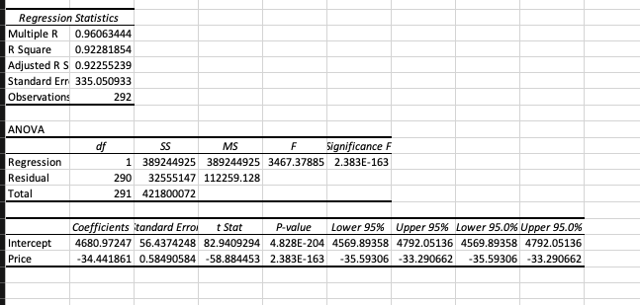

Other Group:
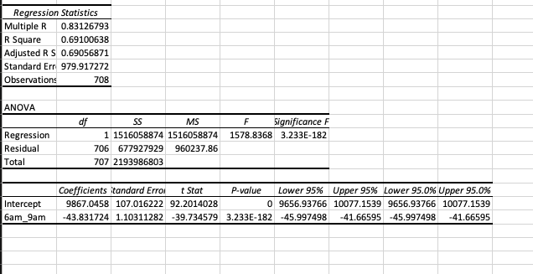

Qno2:
Using the linear demand functions, I calculated the revenue-maximizing price for each group:
- Best student price: 67.97
  - Revenue: 159,047
- Best other-member price: 112.55
  - Revenue: 555,297
Total revenue with two different prices: 714,344
I also computed the optimal single flat price using the pooled model:
- Single best price: 85.2431
  - Revenue: 636,051
Revenue gain from using two different prices instead of one: 78,292
Using separate prices increases revenue because the two groups have different demand sensitivities.

Qno 3:
For this part, I ignored the linear demand models and used the empirical MaxWTP data directly. For each price in the grid, I calculated the actual number of students and other members whose MaxWTP exceeded that price, scaled it to the NYHC population, and computed revenue.
The price that generated the highest revenue for each group was:
- Student empirical best price: 75
  - Revenue: 20,100
- Other-member empirical best price: 110
  - Revenue: 682,783
These empirical optimal prices differ from the linear-model prices because the empirical demand curve is a step function based on actual counts, whereas the linear model smooths the relationship into a straight line. The empirical method does not account for elasticity, so it produces results based solely on discrete WTP thresholds. In contrast, the linear model approximates how quantity responds to price across the entire range.
For students, the empirical and linear optimal prices differ more noticeably, suggesting that the linear model does not fit student demand as well.
For other members, the empirical and linear optimal prices are closer, showing that the linear model is a reasonable approximation for that group.

Qno4:
In Question 4, NYHC wants to prevent congestion by ensuring that no time slot exceeds 320 sessions. To do this, I:
- Used the linear demand models to calculate total student and other-member demand at any price.
- Allocated each group’s demand across the six time slots based on the preferred-time-slot shares from the survey.
- Computed total demand in each slot.
- Used Excel Solver to choose student and other prices that maximize total revenue while keeping all six slots below the 320-session limit.
Results
- Optimal student price under capacity: 132.70
- Optimal other-member price under capacity: 193.04
At these prices:
- Student demand: 108
- Other-member demand: 1,392
- Total revenue: 282,808
One or more peak slots (especially 6–9am and 5–9pm) were exactly at or near the 320 limit, meaning the capacity constraint was binding. As a result, both prices increased compared to the no-capacity case. Capacity forces NYHC to raise prices to reduce demand in crowded periods.
Why the optimal other-member price was 193
The optimal other-member price Solver returned was higher than the highest MaxWTP observed in the data (around 150). This happens because the linear demand curve is only an approximation. It continues to predict positive demand even at prices above the maximum observed WTP. Solver uses this approximation when optimizing revenue and therefore can select prices that fall outside the realistic WTP range.
In reality, no members would buy at such a high price, but the linear model does not inherently enforce this. As a result, Solver may return a price that is mathematically optimal for the linear approximation, even if it is unrealistic from the perspective of actual WTP data

